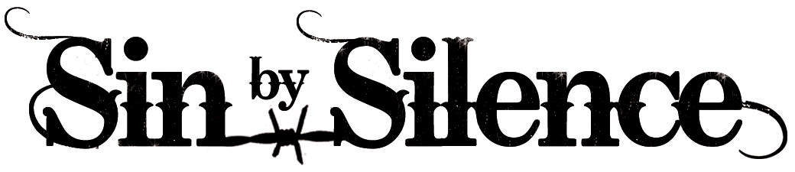
Documentary Backgrounder

SYNOPSIS

From behind prison walls, SIN BY SILENCE reveals the lives of extraordinary women who advocate for a future free from domestic violence.

Inside California's oldest women's prison, the first inmate-initiated and led group in the U.S. prison system was created by inmate Brenda Clubine to help abused women speak out and realize they are not alone. Over the past two decades, the women of CWAA, Convicted Women Against Abuse, have changed laws for battered women and raised awareness for those on the outside.

SIN BY SILENCE is an emotionally packed documentary that tells the personal and shocking stories of these courageous women who have learned from their past, are changing their future and, most importantly, teach how domestic violence affects each and every person.

ABOUT THE FILM

The normalization of violence against women, relationship complexities and the pervasive cultural ideology that private matters should remain private have made domestic violence the number one cause of injury to women today – more than rape, muggings and automobile accidents COMBINED.

With unprecedented access inside the California Institution for Women, SIN BY SILENCE offers a unique gateway into the lives of women who are domestic violence’s worst-case scenarios: women who have killed their abusers.

Brenda Clubine endured broken bones. Skull fractures. Her face bruised and battered. By the time Brenda was put behind bars, for killing her husband in 1983, she felt worthless. She received a sentence of 15 years to life. She had to give up her son for adoption. She thought she was the only woman in her situation. But, Brenda soon discovered that she shared common experiences of love turning violent with many of her fellow inmates.

After years of meeting on the yard and telling each other their whispered stories, an inmate-initiated and led group was born inside the prison in 1989, called Convicted Women Against Abuse (CWAA). Brenda’s revelation inspired this support group, the first group of its kind in the entire US prison system. The goal of the group is to help women inside prison break the silence about abuse and learn more about how they can help others stop the cycle of violence. Over the past 20 years, since the group was established, many familiar faces remain…

LaVelma killed her husband, a pastor and pillar in the community. She never spoke a word to her family, or church members, that her husband beat her on a regular basis. She was embarrassed what others would think about what was happening behind closed doors. She had faith that her husband would change.

Joanne tried to leave, but there were no options available to her. No shelters. No hotlines. No help from the police. Yet, she knew she couldn't live in her car with two kids and temperatures dropping. So, she continued to go back and the abuse for her, and her kids, got worse.

Glenda ran over her husband with her car in a public parking lot. He died at the scene. A cut and dry murder case. Yet, why would a 45-year-old woman with no prior criminal history brutally kill her husband?

Instead of fighting a system that does not fully comprehend the complexities of abuse, CWAA led an initiative to help educate the system. Through careful orchestration of letter writing campaigns, media coverage, and senate hearings, a movement was born and laws were changed. And, finally, for Brenda Clubine the flicker of hope begins to grow that her freedom from prison lies moments away.

Like many of the CWAA women, Brenda’s years of inflicted abuse were never fully revealed in her trial since, prior to 1992, California law did not allow a legal defense to include evidence of battering. But because of CWAA’s advocacy, new laws were set in place in 1992 and 2002 that allow incarcerated survivors to utilize the defense of Battered Women’s Syndrome and even challenge their original conviction. Because of those efforts, battered women across the country are currently receiving lesser sentences and are now permitted to seek a new trail if they were convicted before the laws recognized the importance of expert testimony on the effects of battering.

After 26 years in prison, on October 22, 2008, Brenda became the 20th CWAA member to gain her freedom. A chance to walk on the beach. A chance to be with her son who she was told had died by his adoptive parents just after her incarceration. A chance to continue her advocacy and be a voice for the women of CWAA in the free world.

Every other Monday for over eight years, the director of SIN BY SILENCE, Olivia Klaus, attended CWAA meetings and built incredibly close relationships with each of the women, carefully capturing their stories for the documentary. Through their stories of terror and hope, the viewer can begin to understand the cycle of violence, the signs of an abuser, and how each and every one of us is responsible for changing the tragedy of domestic violence.

# # #

